Partner with "Fighting the Darkness" - September 13, 2025
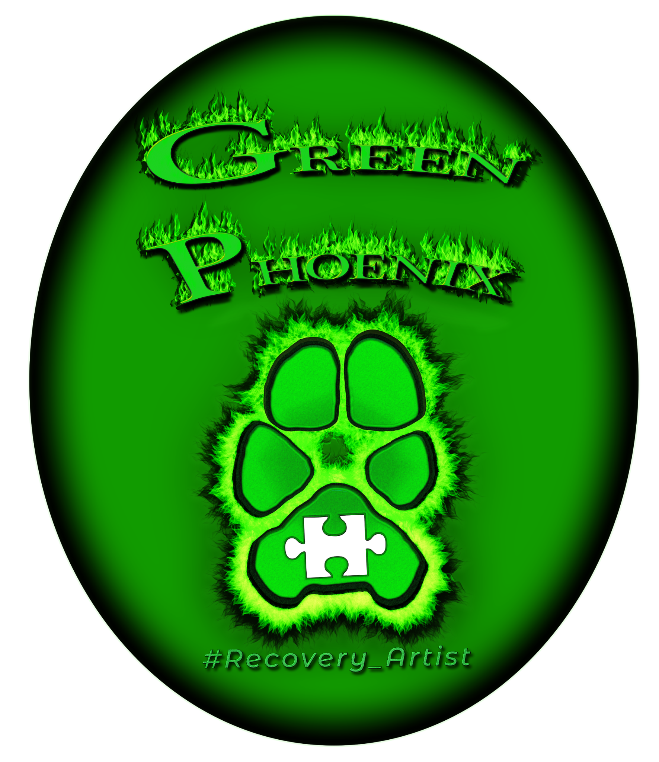

On behalf of The Green Phoenix, we are thrilled to hear about your interest in becoming a valued sponsor or vendor at our upcoming event, "Fighting the Darkness," taking place on September 13, 2025, from 11:30 a.m. to 1:00 p.m. at the Ben Robertson Community Center.
"Fighting the Darkness" is an in-person event dedicated to shedding light on the crucial topic of mental health and raising awareness about suicide prevention. This is our 4th year presenting this event, and we are continually striving to enhance its impact. The event is free and open to the entire community, designed to create an open dialogue surrounding mental health and suicide prevention, with the primary aim of debunking myths, fostering understanding, and providing resources for support.
The event will consist of a powerful Panel Discussion and an inspiring Art Exhibition. Our diverse panel includes a Therapist/Crisis Counselor, First Responder, Pastor, Suicide Loss Survivor, and Suicide Attempt Survivor, all contributing unique perspectives to reduce stigma and promote honest conversations. Additionally, local artists will showcase their work, expressing their mental health journeys through art, emphasizing the role of art in mental health expression. Resource tables will also be available to empower attendees to continue the conversation and seek support.
We believe that a partnership with [Sponsor/Vendor Company Name] would be mutually beneficial. Your involvement would not only demonstrate your commitment to community well-being through education and engagement but also provide an unparalleled opportunity to enhance your brand visibility and connect directly with an engaged community audience passionate about mental health awareness.
To facilitate your participation and maximize your exposure, we have outlined several sponsorship tiers below. All sponsorship tiers include a complimentary vendor table, allowing you to directly engage with attendees and showcase your organization. Your contribution will directly support the resources and accessibility of this vital community event.
Sponsorship Tiers:
- Title Sponsor - $300 (Already Filled)
  - Most prominent logo placement on all event materials (digital and print)
  - Recognition as the lead sponsor in all event announcements and social media posts
  - Verbal recognition during the event opening and closing remarks
  - Opportunity to display your company banner at the event (provided by sponsor)
  - Includes a premium vendor table with prime placement
- Supporting Sponsor - $150
  - Prominent logo placement on all event materials (digital and print)
  - Recognition in event announcements and social media posts
  - Verbal recognition during the event
  - Includes a complimentary vendor table
- Community Partner - $75
  - Logo placement on the event website
  - Mention in a collective thank you on social media
  - Includes space at a shared vendor/resource table
Your support will directly contribute to the success of "Fighting the Darkness" by enabling us to provide this vital mental health awareness and suicide prevention event free of charge to the community. We are confident that your participation will be a valuable investment and a rewarding experience.
We would be delighted to schedule a brief call or meeting to discuss these opportunities further and answer any questions you may have. Please contact Heather Croas at 678-665-1012 or recovery.artist2019@gmail.com for more information on sponsorship opportunities.
Thank you for considering this invitation. We look forward to the possibility of partnering with you to make "Fighting the Darkness" a resounding success.
Sincerely,
Heather Croas
The Green Phoenix
recovery.artist2019@gmail.com
678-665-1012

